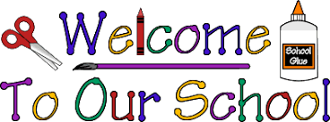
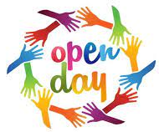

St. Paul’s Primary School
Open Day 2023

All prospective P1 pupils (September 2023) and parents are invited to come and see our school on

Wednesday 11th January from 3.30pm – 4.30pm

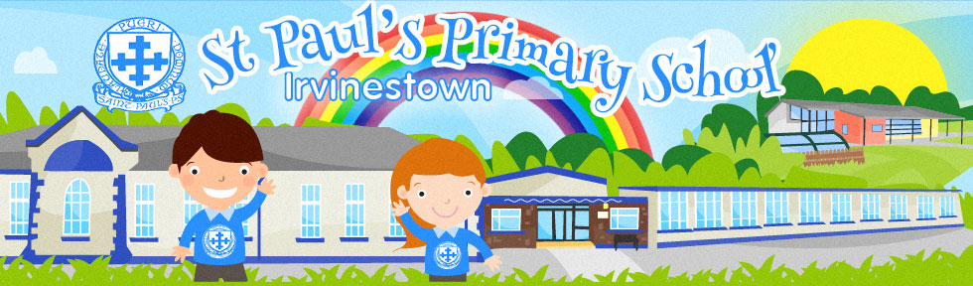
We look forward to meeting you

